REGISTRATION FORM -- 5779 (2018-2019)
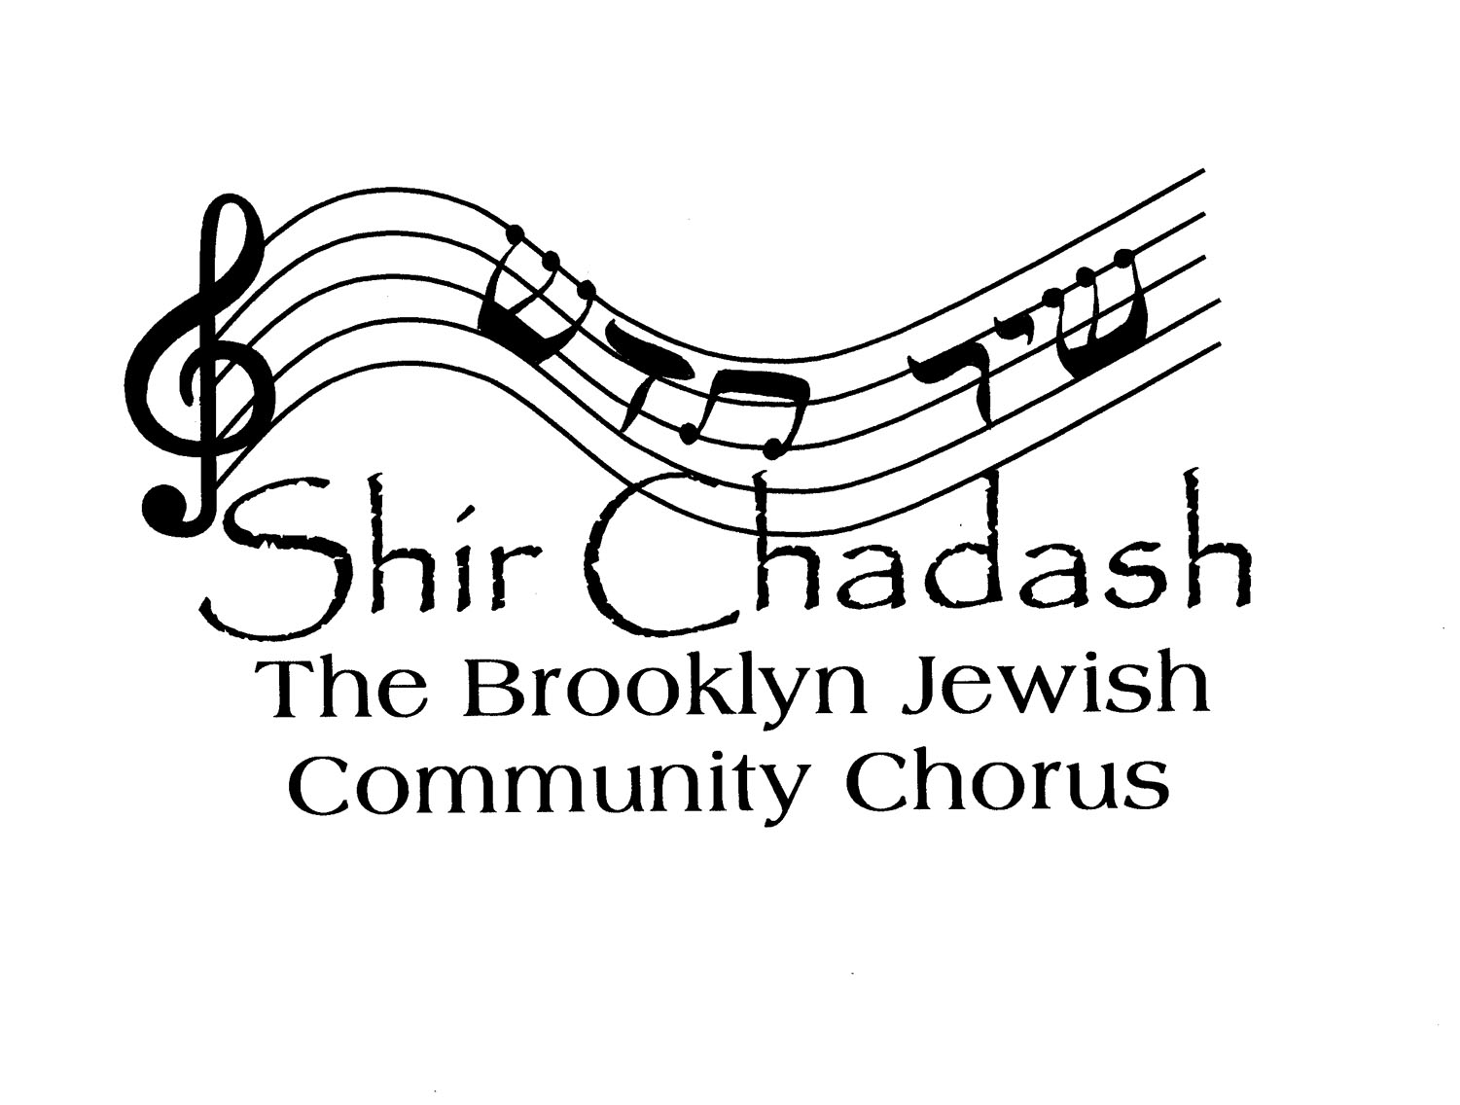

PLEASE FILL IN ALL INFORMATION:

NAME: ________________________________

VOICE PART: (S, A, T, B) _________________

HOME STREET ADDRESS: ____________________________________

CITY, STATE, ZIP CODE: _____________________________________

DAYTIME PHONE: ____________ EVENING PHONE: _______________

CELL PHONE: _____________________________________________

E-MAIL ADDRESS: _________________________________________

OCCUPATION: ____________________________________________

DO YOU BELONG TO A SYNAGOGUE? -- YES/NO (IF YES, WHICH ONE(S)?

_________________________________________________________

ARE YOU INVOLVED WITH OTHER JEWISH, MUSICAL, OR LOCAL ORGANIZATIONS/COMMUNITIES? (please list)

I have read and agree to follow the policies of Shir Chadash: The Brooklyn Jewish Community Chorus.

Signed ______________________________________________

Shir Chadash: The Brooklyn Jewish Community Chorus

Date______________

Dues______ Additional Contribution____ Total Received: _____________

Received By_________________________

