REGISTRATION FORM – 5783
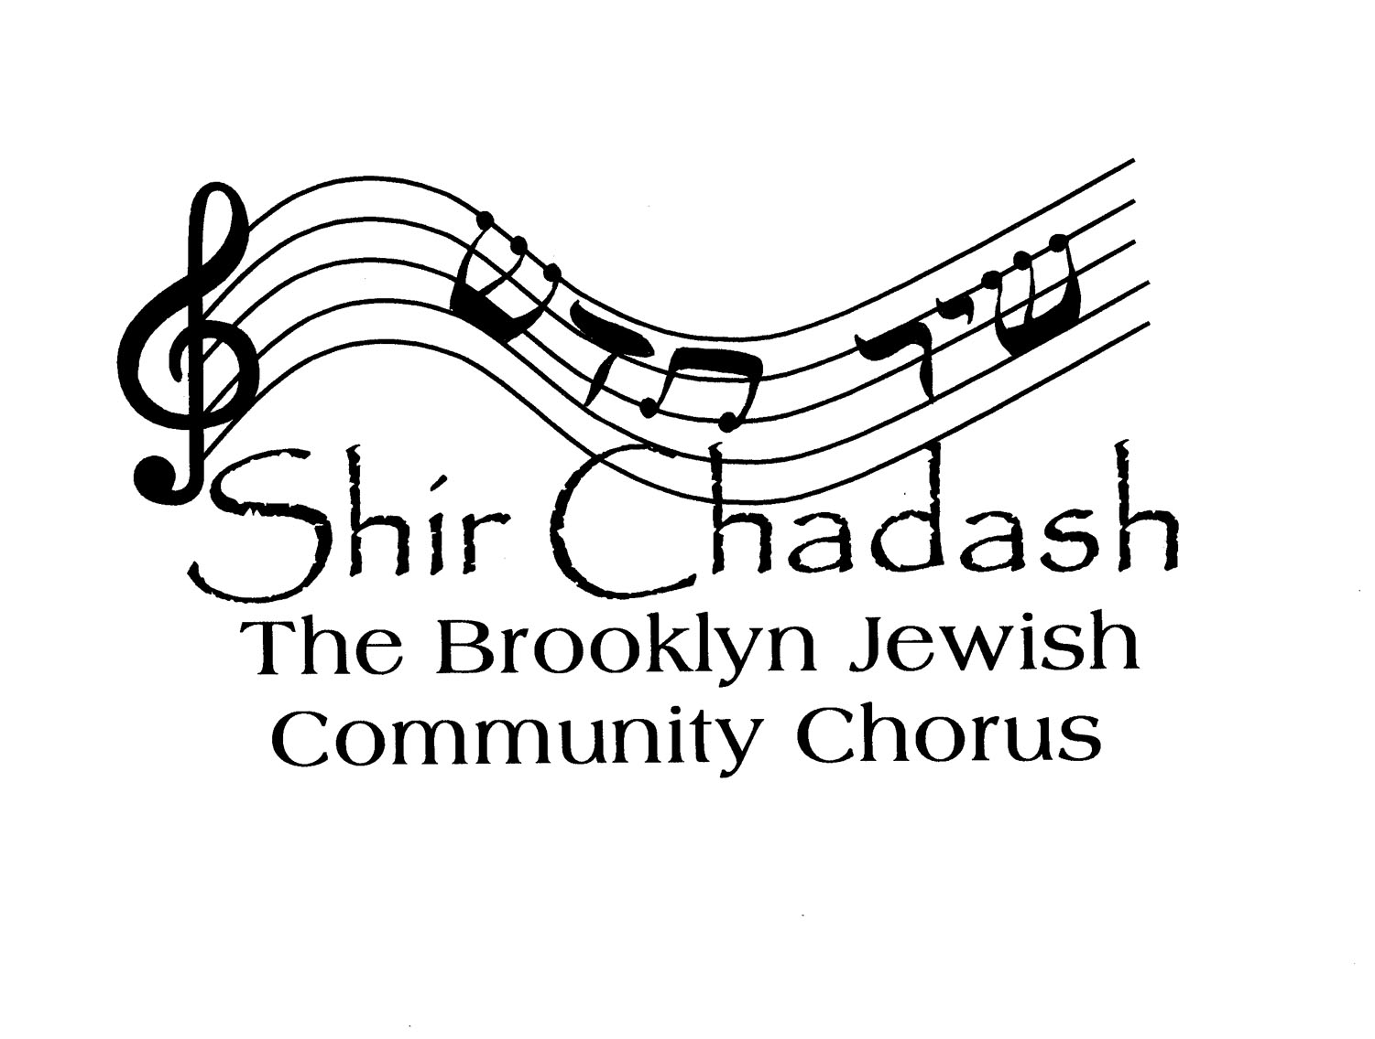
(2022-2023)

PLEASE FILL IN ALL INFORMATION:

NAME: ________________________________

VOICE PART: (S, A, T, B) _________________

HOME STREET ADDRESS: ____________________________________

CITY, STATE, ZIP CODE: _____________________________________

DAYTIME PHONE: ____________ EVENING PHONE: _______________

CELL PHONE: _____________________________________________

E-MAIL ADDRESS: _________________________________________

OCCUPATION: ____________________________________________

DO YOU BELONG TO A SYNAGOGUE? -- YES/NO (IF YES, WHICH ONE(S)?

_________________________________________________________

ARE YOU INVOLVED WITH OTHER JEWISH, MUSICAL, OR LOCAL ORGANIZATIONS/COMMUNITIES? (please list)

I have read and agree to follow the policies of Shir Chadash: The Brooklyn Jewish Community Chorus.

Signed ______________________________________ Date____________

Membership dues are $275 per year.
Please make your payment through PayPal, by going to the Shir Chadash website, ShirChadashChorus.org and clicking the DONATE button. Or you can send this form, with a check made out to Shir Chadash: The Brooklyn Jewish Community Chorus, to Shir Chadash c/o Tori Rosen, 726 Argyle Road, Brooklyn, NY 11230.

