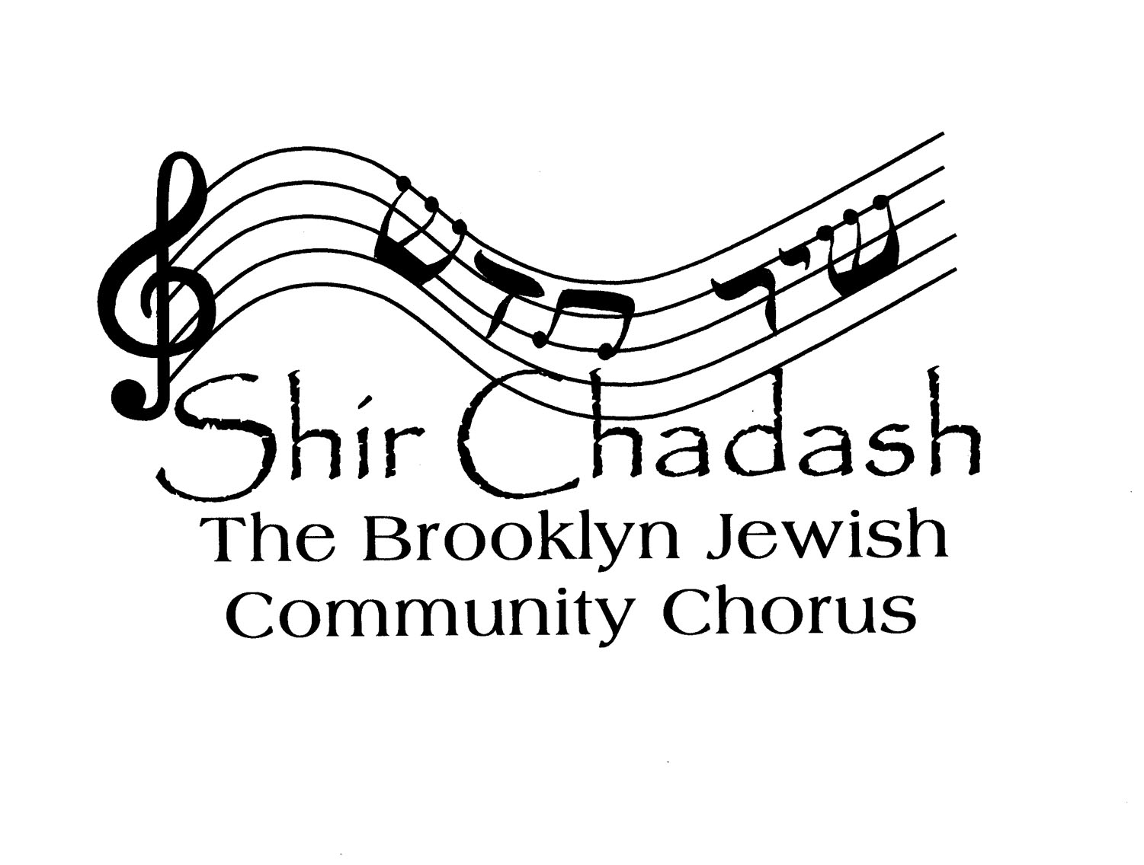 WELCOME to SHIR CHADASH:

THE BROOKLYN JEWISH COMMUNITY CHORUS

an independent, not-for-profit community choir now in its third decade!

MEMBERSHIP POLICIES – Fall 2023

Shir Chadash members have a love of Jewish music and an interest in improving their musical skills. We improve, both individually and as a group, through weekly rehearsals and individual practice and preparation for those rehearsals
- Members must commit to attending weekly rehearsals, which will be at Park Slope Jewish Center on Tuesday evenings from 7:30PM-9:30PM.
- In addition to weekly rehearsals, members should practice on their own. Recorded voice parts for self-study will also be available via email or on our website.
- All members must be fully vaccinated against Covid-19. In addition, if you are feeling ill, running a fever, have a sore throat, have tested positive or been exposed to someone who tested positive for Covid, please DO NOT COME TO REHEARSAL!

Members must pay YEARLY TAX-DEDUCTIBLE DUES of $275
- Payments may be made by via PayPal or by check. Checks should be made out to Shir Chadash and mailed to Shir Chadash, c/o Tori Rosen, 726 Argyle Road, Brooklyn NY 11230. You can pay through PayPal by going to our website, ShirChadashChorus.org and clicking on the DONATE button. You can use a credit or debit card, or your own PayPal account.
- Members who need to make other financial arrangements are asked to speak with our Treasurer.

We COMMUNICATE PRIMARILY BY E-MAIL. All members must have an e-mail address or an e-mail “buddy.”

Shir Chadash has NO FULL-TIME or PART-TIME STAFF. We are a volunteer-run organization and depend on our members for support. Members are strongly urged to help with tasks that contribute to the choir’s continued existence and well-being.

For more information, send an email to ShirChadashBJCC@gmail.com

Rehearsal Etiquette

We are working on the assumption that we will be able to have all our rehearsals in person at PSJC. We will follow the safety protocols established by PSJC, and may have to make some adjustments if circumstances warrant as the year goes along. We’ll communicate the details of any changes as we get them. Here are a few general reminders about rehearsals:

Please be on time. We will begin rehearsals promptly at 7:30. We encourage you to arrive a few minutes early to greet each other and settle in.

Bring your music (all of it!) every week.

Bring a pencil and a highlighter to rehearsal, so that you are prepared to note any changes or instructions in the score.

Please read the weekly rehearsal notes, and when there are comments that relate to your voice part, make a note in your score.

Shir Chadash Rehearsal Schedule -- Fall 2023

All rehearsals will be held at PSJC on Tuesday evenings from 7:30 to 9:30 pm.

August 29 - rehearsal for Selichot Across Brooklyn singers only 7:30-9:00
September 5 - rehearsal for Selichot Across Brooklyn singers only 7:30-9:00
September 12 - first full rehearsal
September 19
September 26
October 3
October 10
October 17
October 24
November 7
November 14
November 21
November 28
December 5 - dress rehearsal 7:00-9:30

December 12 - Winter Concert at PSJC 7:00

